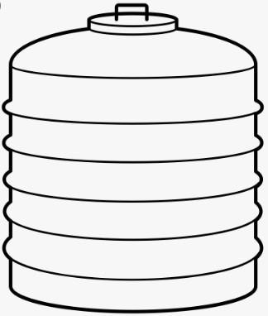Amador Fire Protection District
Emergency Water Storage Tank Standard
Amador County Ordinance #15.30.360

A water tank is NOT REQUIRED if a hydrant is located
within 1000 ft. of the property.
- 2500 gallons minimum water supply for fire department use only.
- Minimum 50 feet from structures.
- Maximum 12 feet from the fire department access road.
- FD access road weight load shall hold 40,000 lbs. during all weather.
- Brass outlet at least 18-inch off the ground.
- Minimum Pipe Size shall be 4 ½-inch.
- Outlet shall be a brass 4 ½-inch N.H.T male threads.
- Minimum 10 square inch air vent shall be provided.
- Pad shall be a minimum 3-inch aggregate rock base and 24-inches wider than the tank.
- A blue reflective address mounted on the tank visible from the roadway.
- Letterings for the mounted address shall be a minimum 4-inch in height with a minimum stroke width of ½ inch.
- Tanks to be constructed of molded plastic, fiberglass or galvanized steel, not less than 12 gauge.
- A water capacity or site glass indicator is optional.

10 Sq. Inch Air Vent Minimum 3/8” Rust Resistant Screen

Site Glass (Optional)
Home
2,500 Gallons Minimum Reflective Blue Address

4” Min Pipe Size
4 ½” Brass (optional) Male Thread
Tanks 50 Ft. Away

18” Min From Grade

3” Min. Rock Base 2 Ft. Wider Than Tank
12 Ft. Max From FD Access Road
A site inspection is required prior to installation of the tank and finalization of the project. Contact Fire Prevention Officer to schedule appointment: (209) 223-6226.
www.amadorfire.org
810 Court Street, Jackson, CA 95642-2132 Rev: 01-07-26

